Welcome to Scholastic Book Orders
September 7, 2018

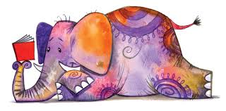
Shop Online: scholastic.com/readingclub
One-Time Class Activation Code: MQ894

Dear Families,

Encouraging reading is one of the most important things we can do to help your child succeed. It can be tough finding the right books to keep them interested, which is why I am so excited that our class will be participating in Scholastic Reading Club this school year.

With Scholastic Reading Club:
- Every book you buy earns FREE Books for our classroom library
- You can choose from handpicked, grade- and reading-level-specific books for your child
- You'll find the best values on a variety of formats, including eBooks
Each month, your child will bring home Reading Club flyers. Together you can choose from books hand-selected by teachers and experts, and then order online or by returning your order form and payment to me.

I'd also love some help growing our classroom Reading Club. If you'd like to help out, please let me know! I'm excited to get our class reading!

Thank you for your support,
Mrs. Gallegos

If This Is Your First Time Ordering Online:
- REGISTER at scholastic.com/readingclub
- ENTER the Class Activation Code at the top of this letter
- CHOOSE from thousands of print titles, value packs, and Storia eBooks
- SUBMIT the order to me by the due date listed on the website
- EARN FREE Books for our classroom too!

FIRST CLASS ORDER DUE DATE IS: FRIDAY, September 28th, 2018

